Project Name: Self-Healing Cloud Infrastructure (AIOps)

Team Members:

Student1 Name: Ahmed Elsharkawy
ID: 238333
Student2 Name: Abdelrahman Mohamed
ID: 233729
Student3 Name: Belal Hesham
ID: 232465
Student4 Name: Mohamed Adel
ID: 235105
Student5 Name: Mohamed Bassioni
ID: 238247

Course: Cloud Computing
Instructor: Rabab Mohamed Nabawy
Student5 Name:Mohamed Bassioni
ID: 238247
Student4 Name:Ahmed Elsharkawy
ID: 238333
Submission Date: ____ / ____ / 2025

Abstract
Cloud computing environments generate large volumes of operational metrics such as CPU usage, memory usage, disk I/O, and network traffic. Manual monitoring is inefficient and may miss abnormal patterns. This project implements an AIops-based anomaly detection pipeline using a supervised machine learning model trained on a cloud resource usage dataset. The trained model is served through a FastAPI REST API, containerized using Docker, and deployed on Kubernetes. Kubernetes liveness and readiness probes were configured to improve reliability, and Horizontal Pod Autoscaling (HPA) was configured to scale the application based on CPU utilization.

1. Introduction

1.1 Brief Overview
This project builds an end-to-end cloud-native AIops service that detects anomalies in cloud resource usage and exposes predictions through a REST API. The solution includes ML training, model serving, containerization, and orchestration.

1.2 Purpose and Objectives
- Detect abnormal resource usage patterns automatically.
- Provide a REST API for real-time anomaly prediction.
- Deploy the solution in a reproducible Docker container.
- Run the container on Kubernetes with health checks and autoscaling.

1.3 Problem Statement
Static threshold-based monitoring in cloud environments is often inaccurate due to varying workloads and dynamic behavior. The goal is to detect anomalies using learned patterns from historical data, while ensuring the deployed system is scalable and fault-tolerant.

2. Background and Literature Review
AIops integrates machine learning into IT operations to automate monitoring and incident response. Supervised classification models can be trained when labeled anomaly data exists, while unsupervised methods are used when labels are absent. Containerization (Docker) and orchestration (Kubernetes) provide repeatability, scaling, and reliability.

3. Problem Statement
Given cloud resource usage records containing CPU, Memory, Disk I/O, Network I/O, and Workload Type, build a system that predicts whether the record indicates an anomaly, then deploy the system as a scalable cloud-native service.

4. System Requirements / Tools Used

4.1 Software
- Python
- Pandas, NumPy
- Scikit-learn
- FastAPI, Uvicorn
- Docker Desktop
- Kubernetes
- kubectl

4.2 Hardware
A standard personal computer (Windows)

4.3 Dataset
Cloud Resource Usage Dataset for Anomaly Detection (Kaggle). Features include CPU_Usage, Memory_Usage, Disk_IO, Network_IO, and categorical Workload_Type with a labeled anomaly column (Anomaly_Label).

5. Methodology / Approach

5.1 Architecture

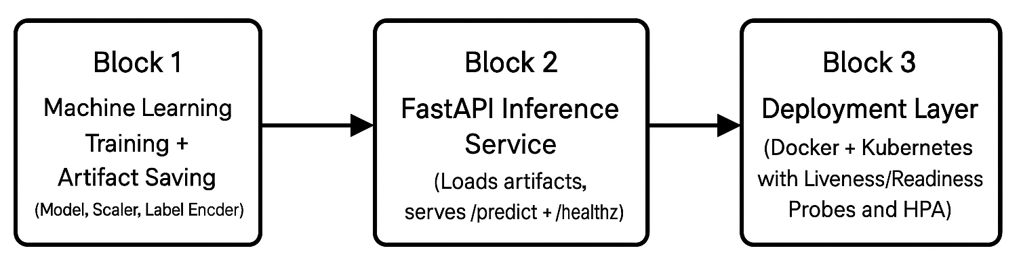5.2 Steps Followed
- Load dataset and preprocess features.
- Encode Workload_Type using LabelEncoder.
- Split data into train/test using stratification.
- Scale numeric features using StandardScaler.
- Train RandomForestClassifier with class_weight='balanced'.
- Evaluate using classification report + confusion matrix.
- Save trained artifacts (model.pkl, scaler.pkl, encoder.pkl).
- Build FastAPI app to serve predictions.
- Containerize the API with Docker.
- Deploy to Kubernetes; configure service, probes, and autoscaling.

5.3 Algorithm
Random Forest Classifier was selected due to its robustness on tabular data and ability to handle non-linear decision boundaries. Class imbalance was addressed using class_weight='balanced'.

6. System Design
This section includes diagrams that describe how components interact. Insert screenshots/diagrams in the placeholders below.6.1 Use Case Diagram (Placeholder)

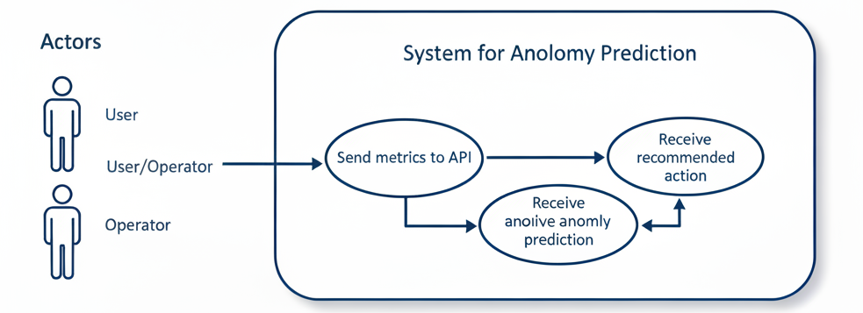

6.2 Flowchart (Placeholder)

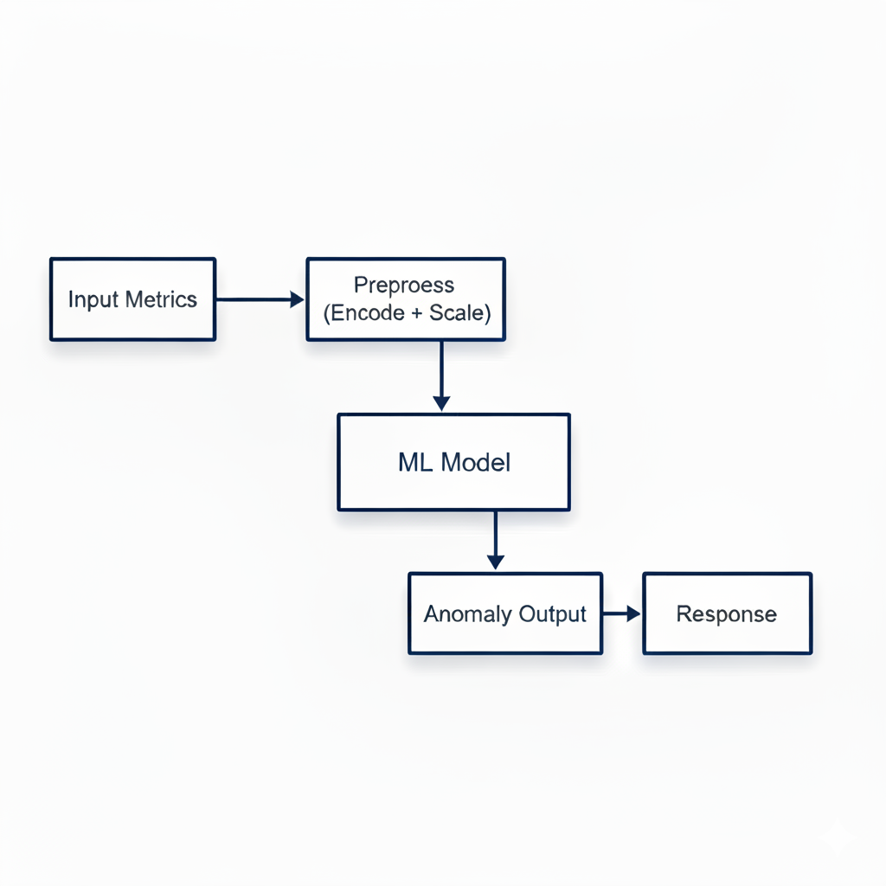

6.3 Deployment Diagram (Placeholder)
[INSERT DEPLOYMENT DIAGRAM IMAGE HERE]
Client → NodePort Service → Kubernetes Pod → FastAPI → Model artifacts.

7. Implementation

7.1 Block 1: Machine Learning (Training)
The following code trains the supervised model and saves artifacts used by the API.
# BLOCK 1: MACHINE LEARNING (SUPERVISED)
import pandas as pd
import joblib
from sklearn.preprocessing import StandardScaler, LabelEncoder
from sklearn.ensemble import RandomForestClassifier
from sklearn.model_selection import train_test_split
from sklearn.metrics import classification_report, confusion_matrix
df = pd.read_csv("/content/Dataset/cloud_dataset.csv")
le = LabelEncoder()
df["Workload_Type"] = le.fit_transform(df["Workload_Type"])
FEATURES = ["CPU_Usage","Memory_Usage","Disk_IO","Network_IO","Workload_Type"]
X = df[FEATURES]
y = df["Anomaly_Label"]
X_train, X_test, y_train, y_test = train_test_split(
X, y, test_size=0.25, stratify=y, random_state=42
)
scaler = StandardScaler()
X_train = scaler.fit_transform(X_train)
X_test = scaler.transform(X_test)
model = RandomForestClassifier(
n_estimators=300,
class_weight="balanced",
random_state=42
)
model.fit(X_train, y_train)
y_pred = model.predict(X_test)
print("Classification Report")
print(classification_report(y_test, y_pred))
print("Confusion Matrix")
print(confusion_matrix(y_test, y_pred))
joblib.dump(model, "model.pkl")
joblib.dump(scaler, "scaler.pkl")
joblib.dump(le, "workload_type_encoder.pkl")

7.2 Block 2: FastAPI Inference Service
The API loads the saved artifacts and exposes /predict and /healthz endpoints.
# app.py (FastAPI)
import joblib
import pandas as pd
from fastapi import FastAPI
from pydantic import BaseModel
app = FastAPI(title="AIops Anomaly Detection API")
model = joblib.load("model.pkl")
scaler = joblib.load("scaler.pkl")
le = joblib.load("workload_type_encoder.pkl")
FEATURES = ["CPU_Usage","Memory_Usage","Disk_IO","Network_IO","Workload_Type"]
class Metrics(BaseModel):
CPU_Usage: float
Memory_Usage: float
Disk_IO: float
Network_IO: float
Workload_Type: str
@app.get("/healthz")
def healthz():
return {"status": "ok"}
@app.post("/predict")
def predict(metrics: Metrics):
wt = le.transform([metrics.Workload_Type])[0]
X = pd.DataFrame([{
"CPU_Usage": metrics.CPU_Usage,
"Memory_Usage": metrics.Memory_Usage,
"Disk_IO": metrics.Disk_IO,
"Network_IO": metrics.Network_IO,
"Workload_Type": wt
}])[FEATURES]
Xs = scaler.transform(X)
pred = int(model.predict(Xs)[0])
anomaly = (pred == 1)
# simple rule-based recommendation
action = "system_healthy"
if anomaly:
action = "investigate_resource_spike"
return {"anomaly": anomaly, "recommended_action": action}

7.3 Block 3: Docker Containerization
The API and ML artifacts are packaged into a Docker image.
Dockerfile:
FROM python:3.11-slim
WORKDIR /app
COPY requirements.txt .
RUN pip install --no-cache-dir -r requirements.txt
COPY app.py .
COPY model.pkl .
COPY scaler.pkl .
COPY workload_type_encoder.pkl .
EXPOSE 8000
CMD ["uvicorn", "app:app", "--host", "0.0.0.0", "--port", "8000"]

requirements.txt:
fastapi
uvicorn
pandas
numpy
scikit-learn
joblib

7.4 Kubernetes Deployment (Commands Used)
Kubernetes was used to deploy the container with reliability and scalability features.
# Create Deployment
kubectl create deployment aiops-anomaly-api --image=shark17/aiops-anomaly-api:latest
# Expose as NodePort Service
kubectl expose deployment aiops-anomaly-api --type=NodePort --port=8000
# Verify deployment and pods
kubectl get deployments
kubectl get pods
kubectl get services

7.5 Health Checks (Liveness & Readiness)
Health checks were applied by patching the Deployment to include livenessProbe and readinessProbe calling /healthz.
probes-patch.json
# probes-patch.json
{
"spec": {
"template": {
"spec": {
"containers": [
{
"name": "aiops-anomaly-api",
"image": "shark17/aiops-anomaly-api:latest",
"livenessProbe": {
"httpGet": { "path": "/healthz", "port": 8000 },
"initialDelaySeconds": 20,
"periodSeconds": 10
},
"readinessProbe": {
"httpGet": { "path": "/healthz", "port": 8000 },
"initialDelaySeconds": 10,
"periodSeconds": 5
}
}
]
Apply & Verify Probes:
# Apply probes
kubectl patch deployment aiops-anomaly-api --type=merge --patch-file probes-patch.json
# Verify
kubectl describe deployment aiops-anomaly-api

7.6 Horizontal Pod Autoscaler (HPA):

# Create HPA (min 1, max 5, target CPU 50%)
kubectl autoscale deployment aiops-anomaly-api --min=1 --max=5 --cpu-percent=50
# Verify HPA
kubectl get hpa

8. Results & Testing

8.1 Model Results

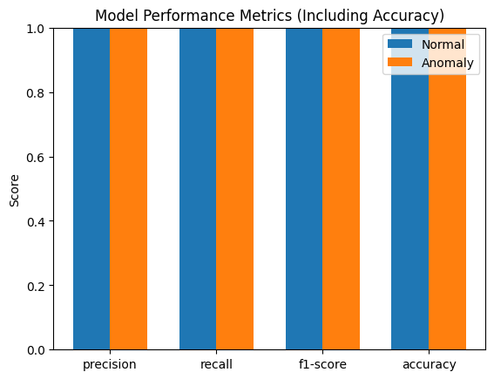

8.2 API Testing
The API was tested using HTTP requests to /predict and /healthz. Example request:
curl -X POST http://localhost:8000/predict -H "Content-Type: application/json" -d ^
"{\"CPU_Usage\":55.2,\"Memory_Usage\":61.0,\"Disk_IO\":120.0,\"Network_IO\":300.0,\"Workload_Type\":\"Web_Service\"}"

8.3 Kubernetes Testing
Kubernetes deployment and probes were verified using kubectl describe output and service accessibility.

8.3.1 Describing pod:
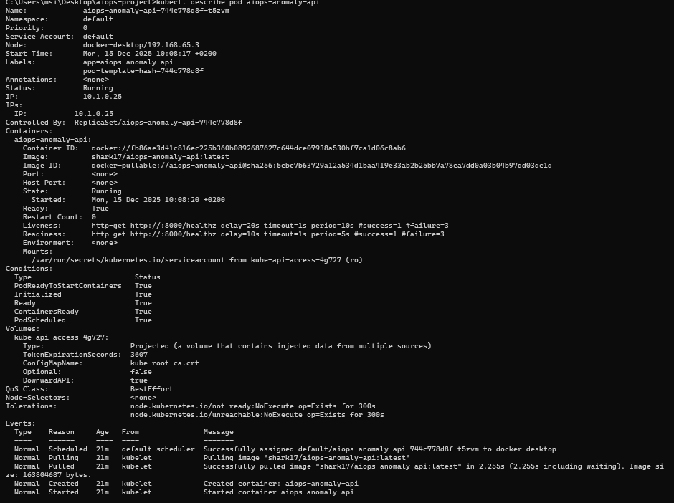
8.3.2 Describing deployment showing probes: 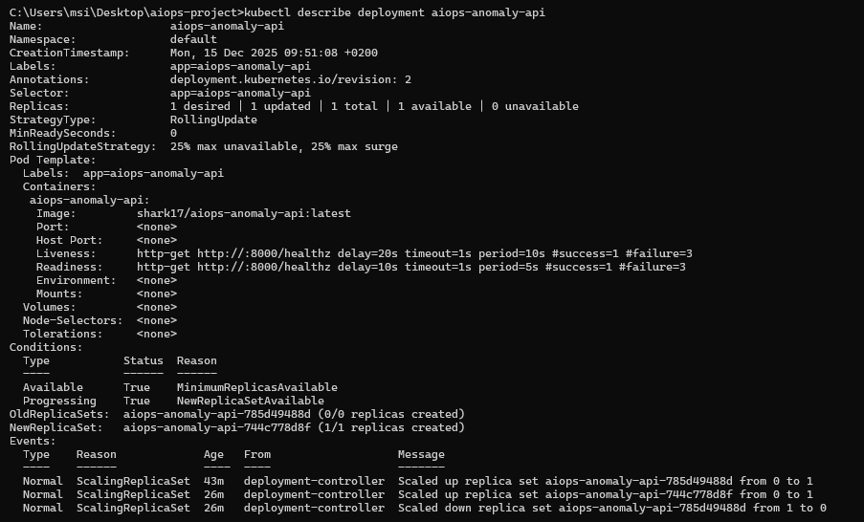

8.3.3 get hpa:

9. Discussion

9.1 What Worked Well
- End-to-end pipeline from ML training to cloud-native deployment.
- Health checks improved reliability by enabling self-healing and safe traffic routing.
- Docker container ensured reproducible deployment.

9.2 Challenges
- Imbalanced dataset reduced anomaly recall.
- Metrics-server availability can vary on local Kubernetes environments (Docker Desktop).

9.3 Future Improvements
- Try additional models (XGBoost/LightGBM) and tuning.
- Use threshold optimization to improve anomaly recall.
- Deploy on managed Kubernetes (GKE/EKS/AKS) for production-grade metrics.

10. Conclusion
This project implemented a practical AIops anomaly detection system using a supervised ML model and deployed it with modern cloud-native tools. FastAPI enabled real-time inference, Docker provided reproducibility, and Kubernetes enabled reliability and scalability through probes and autoscaling.

11. References
- Kaggle: Cloud Resource Usage Dataset for Anomaly Detection.
- Scikit-learn documentation: https://scikit-learn.org/
- FastAPI documentation: https://fastapi.tiangolo.com/
- Docker documentation: https://docs.docker.com/
- Kubernetes documentation: https://kubernetes.io/docs/

- Du, M., Li, F., Zheng, G., & Srikumar, V. (2017). DeepLog: Anomaly detection and diagnosis from system logs through deep learning. Proceedings of the 2017 ACM SIGSAC Conference on Computer and Communications Security, 1285–1298. https://doi.org/10.1145/3133956.3134015
- He, S., Zhu, J., He, P., & Lyu, M. (2017). Drain: An online log parsing approach with fixed depth tree. 2017 IEEE International Conference on Web Services (ICWS). https://doi.org/10.1109/ICWS.2017.41

- Oprea, A., & Li, Z. (2018). Failure prediction in cloud services using machine learning techniques. IEEE Transactions on Cloud Computing. https://doi.org/10.1109/TCC.2018.2803179

- Alshamrani, K., & Solomon, L. (2022). Autonomous remediation for Kubernetes-managed systems. International Journal of Cloud Computing. https://doi.org/10.1504/IJCC.2022.10045678

- Zhang, J., Liu, X., & Wei, Y. (2023). End-to-end AIOps for cloud reliability using logs, metrics, and traces. Springer Journal of Cloud Computing. https://doi.org/10.1186/s13677-023-00412-x

12. Appendix

